**EMAIL PRESS RELEASE**

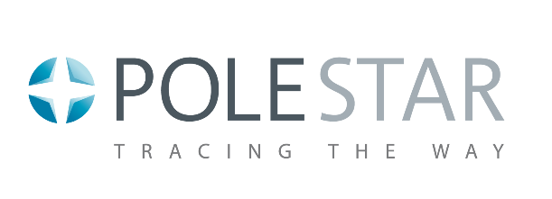**CONTACT INFORMATION:**

**Pole Star**

**+33 534 609 520**

[**Sales@polestar.eu**](mailto:Sales@polestar.eu)

**FOR IMMEDIATE RELEASE**

**MEDICA 2019 in Dusseldorf: the number of visitors to Pole Star exceeds expectations**

Nov 26, 2019 Toulouse, France – A resounding success at MEDICA 2019 in Dusseldorf

MEDICA 2019, which drew 121,000 visitors, is over.

The time has come to assess the main outcomes for Pole Star.

This year more people than ever visited the Pole Star booth, including over 50 qualified visitors. Throughout the four day event, Pole Star performed live demonstrations of the NAO Track solution for asset tracking and people location. Special thanks to the visitors who came especially to MEDICA to discover and test the Best-In-Class NAO© Track solution and meet with the Pole Star team.

Among the 6000+ exhibitors at MEDICA 2019, Pole Star was the only company showcasing an asset tracking and people location solution dedicated to Healthcare.

The show was the ideal opportunity to talk about healthcare professional requirements and expectations, and Pole Star value proposition.

In hospitals, location based services deliver unprecedented value to patients, staff and a broad range of departments. The Pole Star real-time people location solution immediately connects patients to caregivers, as well as visitors, decreasing wait times and empowering staff to focus on providing the best possible care. This means greater peace of mind and improved security and comfort for everyone. Real-time location of assets such as beds, wheelchairs, medical pumps and much more, improves efficiency and reduces wasted resources. In particular, the outpatient surgery department also benefits from optimized use of space and assets for a more efficient, smoother and more comfortable patient journey.

Take a look at the many benefits NAO Track has delivered to an outpatient surgery department at the healthcare Courlancy group in Reims, France



Pole Star based in Toulouse (Fr) and in Chicago (Il), pioneering and leader in the Indoor location technologies develops indoor location solution dedicated to healthcare domain. Pole Star relies on an highly skilled network of vertical integrators and distributors. The pole Star solutions are in operation in more than 35 countries.

[](https://vimeo.com/polestar360)[](https://www.linkedin.com/company/2549048/)[](http://twitter.com/PoleStar_)

Follow us :

Last news on : <https://www.polestar.eu/about/news/>

***